Today’s session:

1. What is cloud computing?

2. What is AWS

3. Different domains in AWS

4. AWS Services

5. AWS pricing options

6. Migrating ur application to AWS Infracture

7. Architecting the USE Case

**-: CLOUD COMPUTING:-**

Before Cloud computing:-

Suppose if u want to hoist the website u need to fallow the below things

1. Buy a stack of servers

2. Keep the peak traffic in mind, buy more servers

3. Monitoring and Maintenance of ur servers.

Before cloud computing Disadvantages:-

1. This set up is expensive

2. Trouble shooting problems can be tedious and may conflict with ur business goals.

3. Since the trafic is varying, ur servers will be idle most of the time.

How resolve the situation: use the cloud computing

How it happens now:-

1. Put ur data on cloud servers and voila. No more buying expensive servers.

2. Scalability. ur server capacity will vary according to traffic.

3. ur cloud provider will manage ur servers, hence no worries about the underlying infracture.

What is cloud computing?

It is the use of remote servers on the internet to store, manage and process data rather than a local server or ur personal computer.

There are basically 3 categories in cloud computing:

**SaaS (Software as a Service)**

* + It allows companies to use software without having to purchase them, which reduces the expenditure of the company drastically, since they are already installed on the cloud server they can be quickly deployed and therefore saves time.

**PaaS (Platform as a Service)**

* + It allows developers to build applications, collaborate on projects without having to purchase or maintain infrastructure.

**IaaS (Infrastructure as a Service)**

* + It allows companies to rent servers, storage space, etc. from a cloud provider.

## What is Cloud Computing?

Cloud Computing often referred to as “the cloud”, in simple terms means storing or accessing your data and programs over the internet rather than your own hard drive.

Everything nowadays is moved to the cloud, running in the cloud, accessed from the cloud or may be stored in the cloud.

**Why we are using Cloud, reason please?**

Primarily because of three reasons:

1. You do not have to maintain or administer any infrastructure for the same.
2. It will never run out of capacity, since it is virtually infinite.
3. You can access your cloud based applications from anywhere, you just need a device which can connect to the internet.

**Service Models:** Cloud has service models they are

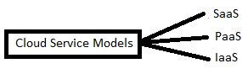

## SaaS(Software As a Service)

In this service the Cloud Provider leases applications or softwares which are owned by them to its client. The client can access these softwares on any device which is connected to the Internet using tools such as a web browser, an app etc.

**For Example:** salesforce.com provides the CRM(Customer Relation Manager) on a cloud infrastructure to its client and charges them for it, but the software is owned by the salesforce company only.

## PaaS(Platform as a Service)

In this service the Cloud Provider gives the ability to the customer to deploy customer created application using programming languages, tools etc that are provided by the Cloud Provider. The customer cannot control the underlying architecture including operating systems, storage, servers etc. Mainly developers use this service.

**For Example:**This service would make sense to you only if you are a developer, since this service provides you a platform for developing applications, like Google App Engine.

## IaaS(Infrastructure as a Service)

In this service the Cloud Provider provides the customer with virtual machines and other resources as a service, they abstract the user from the physical machine, location, data partitioning etc. If the user wants a Linux machine, he gets a linux machine, he will not worry about the physical machine or the networking of the system on which the OS is installed, simple.

**For Example**AWS(Amazon Web Services) is IaaS, like [*AWS EC2*](https://www.edureka.co/blog/ec2-aws-tutorial-elastic-compute-cloud/).

The diagram below, summarizes the differences b/w IaaS, PaaS and SaaS

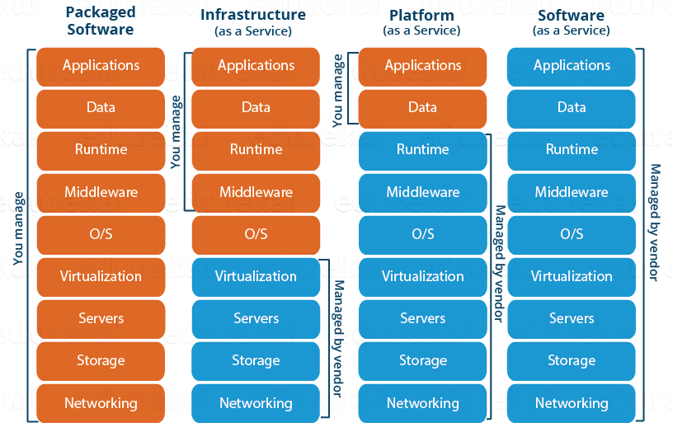

**Cloud Deployment Models:-** Cloud deployment models are

1. Public Cloud
2. Private Cloud
3. Hybrid Cloud

**Public Cloud:**

In a public cloud deployment mode, the services which are deployed are open for public use and generally public cloud services are free. Technically there may be no difference between a public cloud and a private cloud, but the security parameters are very different, since the public cloud is accessible by anyone there is a more risk factor involved with the same.

**Private Cloud:**

A private cloud is operated solely for a single organization; it can be done by the same organization or a third-party organization. But usually the costs are high when you are using your own cloud since the hardware would be updated periodically; security also has to be kept in check since new threats come up every day.

**Hybrid Cloud:**

A hybrid cloud consists the functionalities of both private and public cloud. How?

**Let’s understand it through an example:** Suppose there is a research company, so they would have some published data and also, data which would still be in research phase. Now anything which is still in research should be kept confidential right? Though your cloud provider may have state of the art security features but then it is still open to public, therefore prone to cyber-attacks.

So to address this risk, you can keep the data still being worked on, in your company’s servers whose access is controlled by the company, and your published data on the public platform, this type of arrangement would be a hybrid cloud.

**What are the advantages of Cloud Computing?**

1. Fast Implementation:

If you’ve been there for a development or implementation of an application, it takes sometimes months or even years to make the application up and running, with cloud you can cut through the time and make things faster.

1. Scalability:

With cloud resources you can always scale up or scale down the no. of resources and users according to your need, the cloud capacity never runs out!

1. Access Anywhere

Applications built on cloud are designed to be accessed from anywhere , you just need an internet connection on a mobile device.

1. No Upfront Costs

Earlier to deploy an application you had to purchase the necessary hardware, build the architecture, purchase software licenses etc, but with cloud all those costs are dramatically reduced and in some cases eliminated.

1. Maintenance Free

Traditionally you would have to patch your software with the latest releases, upgrade your hardware and also troubleshoot faults in your system at the hardware level, but with cloud you don’t have to worry about the maintenance of your hardware; it will all be managed by your cloud provider.

1. Better Security

An Independent study found that yearly a medium scale company loses around 260 laptops, this is a loss to the company not in monetary terms, but the data that was there on the laptop is valuable, with Cloud you don’t have to worry about that, all your data is stored in a centralized secure location.

**Note:-**

1. Increasing & decreasing these resources is called Elasticity.
2. Only increasing is called Scaling.

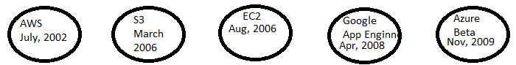

What is Virtual Private Cloud (VPC)?

VPC is ur private section of AWS , where u can place AWS resources , and allow/restrict access to them.

What is RDS?

RDS is AWS provided database service. Commonly used for things like customer account information and cataloging inventory.

What is Amazon S3?

Amazon S3 is a massive storage bucket.

Explain about AWS Global In-fracture?

Amazon EC2 is hosted in multiple locations world-wide.

These locations are composed of regions and Availability Zones.

Each region is a separate geographic area. Each region is completely independent.

Each region has multiple, isolated locations known as Availability Zones. Each Availability Zone is isolated, but the Availability Zones in a region are connected through low-latency links.

